Can I Put a Tracker in My Wallet?

Keeping a tracker in your wallet can save up a lot of time for searching. You can put a tracker in your wallet and the best available wallet tracker can transmit noise signals from 100-200 feet.

## Can I put a tracker in my wallet?

There is a kind of tracker of different ranges to cover and also a kind for multi-purpose usage. Usually, the rectangular RF trackers have multiple buttons to notify you about your car, pet, keys, and many more. They might be tough to handle.

### Regular Trackers

Generally, the RF trackers have a rectangular, or circular chips sized receiver inside your wallet, and there is a high chance of dropping it while the run. As it’s small in size and a coin-like item. But these trackers can be helpful in case tracking multiple items with one controller.

### Fit for the wallet

However, the wallet is a must thing of concern and you better choose wisely. A tile tracker is a card-like shape or precisely a mini tile shaped that will easily fit into your wallet. Most importantly no fear of losing it.

So, you can put your tile tracker in the cardholder pocket of your wallet and assure of keeping yourself updated. Another flexibility is you can either use a remote or use your phone app to monitor the tracker. But often it is suggested to depend on a remote rather than a phone.

## How a tracker relocates the wallet?

The function of any kind of tracker is dependent on four parameters. Descriptive follow-ups are also linked up here <https://www.rollingstone.com/product-recommendations/lifestyle/best-smart-trackers-gps-wallet-1027018/> The receiver, tracker, or transmitter, range of function, and power.

### Transmitter

A transmitter is your app clickables or remote which transmit the signal that you are searching for a pair. The other end of the pair is the receiver. 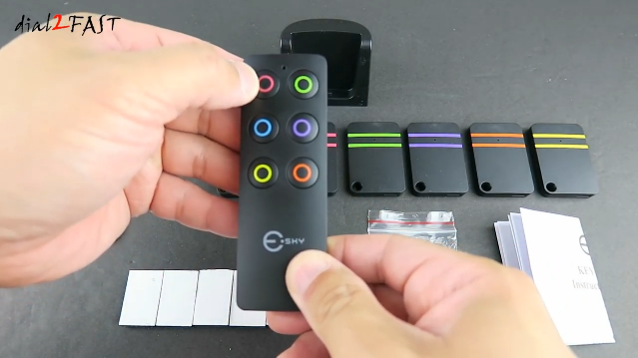

### Receiver

Receivers are attached to your wallet or kept inside the wallet. When it gets the proper signal from the transmitter it will make a sound and you know how to follow the place it is kept.

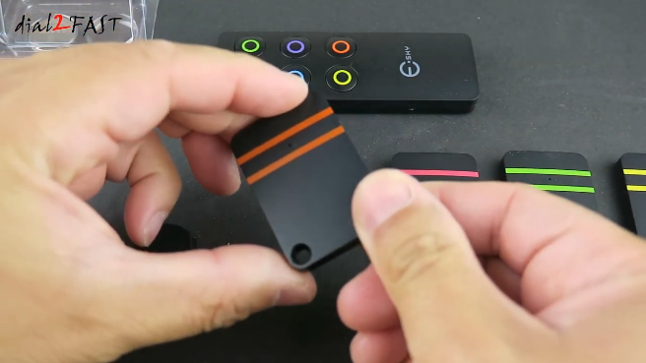

### Range

Commonly the wide range for the signal is around 100-200 feet but the more this range is the better your experience will be. Trackers are not well applicable in the case of electronics items mostly as the system might feel dizzy.

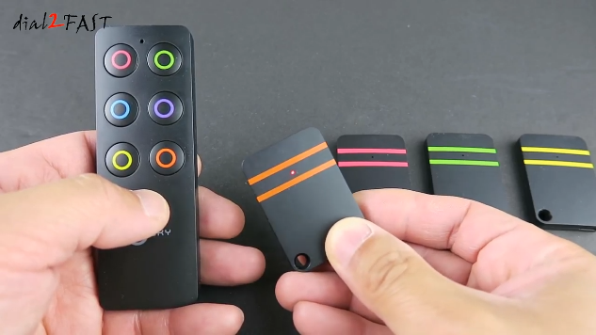

### Power system

Trackers come with very poor battery life. For better service, you can customize a high volt battery to assist your tracker. If the power is down, a great range of over will fall automatically so it is a significant part to focus on after you decide which type of tracker you choose.

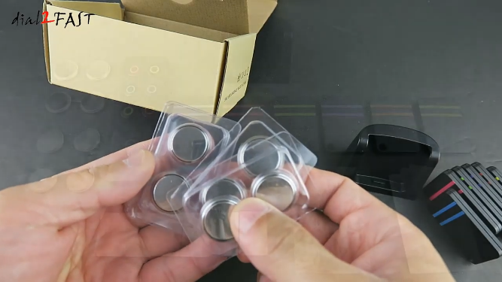

The following video will clear the conception regarding the components and the functionalities. <https://www.youtube.com/watch?v=J8fDE0B2o-0>

## What is the best tracker on market?

A few have earned the user’s satisfaction and the most popular one is the Chipolo. It has brought the thinnest tracker in 2021 and it’s the most hyped one lately. The dimension is 54 x 54 x 2.4 mm which almost near a stack of two credit cards.

Another one is the Tile slim tracker, which is created slim-like tile. These are also thin but similar to nearly three stacks of credit cards. They boast almost 200 feet of coverage. 2021’s best trackers visual is linked here, <https://youtu.be/SvZe0VZu8P0>

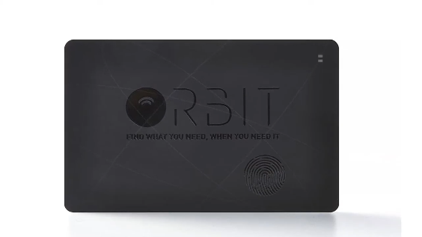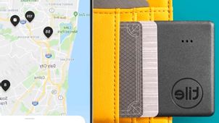

Find key wireless RF locator, Simjar wireless RF tracker, Esky wireless RF item locator, are the next range of choices. But they have a limited range of coverage.

## Is it legal to use a tracker?

In the initial stage, it is legal to use a tracker and you are not to face any penalty. After all, it’s all about just finding your “hide and seek” loving appliances.

## FAQ

How do I connect the tracker with my phone app?

Tile and Chipolo like trackers allow Bluetooth functionality so you can simply pair your device with the tracker and get notified as per directions.

How long is the battery life?

Usually, the battery can give service for 6 months or maybe for 2 years straight. Some enable rechargeable facilities and some have replacement options.

Are wallet trackers water-resistive?

Yes, some are waterproof like the Tile trackers. Most Tile trackers give a long experience and give a wider range of coverage.

## Conclusion

Searching can be tiring and when it’s an urgent case you know how painful the situation is. Even if we have the flexibility of plastic money now, still a wallet is irreplaceable in many cases.

A wallet tracker can be just the handy thing, with a Bluetooth pairing. Just press the button and get to know where it is. This will make your day less tough and give a booming start in a hypothetical sense.